An English version of Dr. Vilhjálmur Örn Vilhjálmsson blog-article Trupulleikarnir á Velbastað which appeared on Fornleifur on 25 August, 2018.
Solving of the mystery of the finger ring from Velbastaður on the Faroe Islands
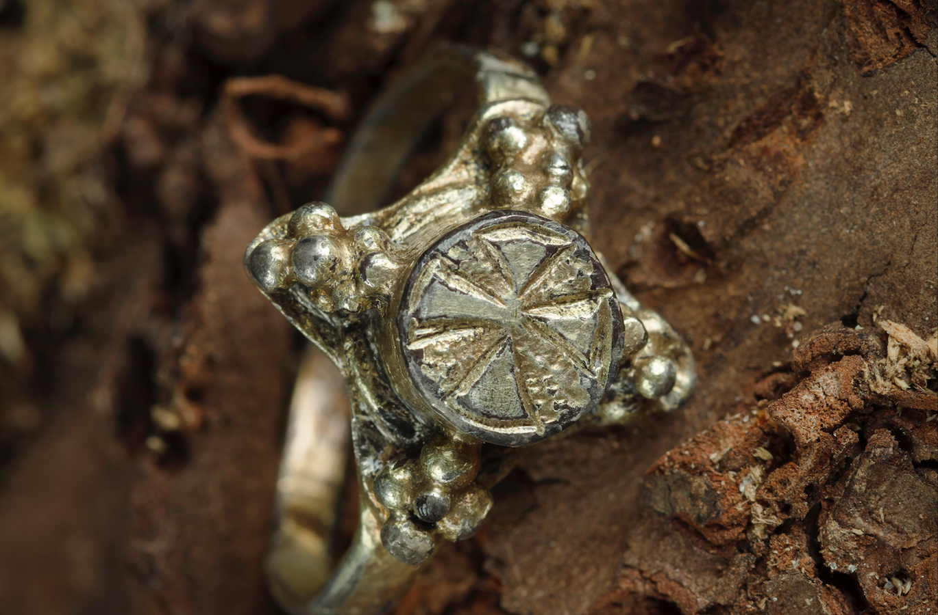
Archaeology in the Faroe Islands is not as over-rated a media-fill discipline during the summer months like it often is in Iceland. In the Faroe Isles there aren´t eight archaeologists per square-mile like there are in Iceland. Despite the more humble circumstances of our relatives on the Faroe Isles, the archaeologists at the Tjóðsafnið (National Museum) of the Faroe Island often find extraordinary interesting antiquities. Occasionally, they are so interesting that everyone is left puzzled.
In the usually wet summer of 2016, a very unique artefact was excavated at Velbastaður (originally thought to have been called Vébólsstaður in the good-old Viking days). Velbastaður is on the largest island of the Faroe Isles, which is called Streymoy. From the first day until now it has been somewhat of a nut to crack for the my colleagues in the Faroe Isles. The artefact in question is a precious finger ring of gilded silver (see illustration above).
Despite the Faroese archaeologist´s contacts to eminent archaeologists in Norway, the British isles (including Ireland) and Denmark, none of the ring-experts at museums in these countries have been able to say anything substantial about the origin or date of the ring from Velbastaður.
During the 2016 excavation at Velbastaður, a fragment of a silver coin was also found. The coin proved to be a rare silver-penny from the coinage of the Anglo-Saxon king Edward the Great of Wessex. The coin dates from the period 910-915 according to numismatic experts in Copenhagen, Denmark.
Whether the ring is as old as the coin-clipping found at Velbastaður, none of the experts whom the National Museum of the Faroe Islands have contacted is able to confirm. One of them has without any clear evidence dated the ring to the period 1100-1300. An Irish archaeologist and former director at the National Museum of Ireland, Ragnall O'Floinn finds it unlikely that the origin of the ring should be sought on the British Isles and suggests a continental origin. That assumption is very much under scrutiny in this article.
Here one can read an excellent article in Faroese by the archaeologist at Velbastaður, Helgi D. Michelsen, which he published in the journal Frøði, and which Michelsen entitles á 'Mysterious finger ring'. On the webpage of the National Museum of the Faroe Island there is also a request to anyone to solve that mystery.
It seems as if the archaeologists on the Faroe Isles have some genuine Faroese Trupulleikar on their hands. Trupulleikar is the Faroese word for a problems. Fornleifur's editor, who recently becoming aware of this ring and the problem, took on the challenge of the National Museum of the Faroe Isles to solve the "mystery", and immediately investigated the matter, believing that he at some stage on his travels on the WWW had seen similar rings in British collections. I believe that the ring from Velbastaður originates from the British isles like the Faroese word Trupulleikar. So the problem had to be solved.
Fornleifur decides to help his Faroese cousins
Determined to help his distant relatives, often defined in Iceland as the Vikings who got sea-sick on the way to Iceland (which by the way is bullocks), the editor of Fornleifur threw himself over the matter. After using not more than an hour on the good old www and in his humble library in the attic, here is a short report of the result of that investigation:
Since the coin-clipping discovered at Velbastaður is well dated and its origins is known, my first thought was to seek the origin of the ring in the same area and in the same era as the coin. The Faroe Isles are after all, just as close to the British-isles as they are to Scandinavia and Iceland, which seemed unlikely origin for the ring from the start.
With a little knowledge of Anglo-Saxon studies, retrieve during my year at the University of Durham during my Ph.D. studies in Denmark, I find it most likely that the ring shows a strong Anglo-Saxon trait, with some influence from Merovingian gold-jewellery in France. The form and the build-up of the ring from Velbastaður is also very similar to quite a famous ring in the elaborate Anglo-Saxon fashion that was found back in the 18th century. One of the most prominent experts of Anglo-Saxon art in Britain is D. Leslie Webster. She believes that ring is from the first half of the 9th century A.D. (See here). The ring in question is a elaborate gold ring with filigree work, which was found in Berkeley in Mercia (the Midlands), where there is mention of a monastery already in 759 A.D. A part of the remains of the monastery have been excavated in recent years.
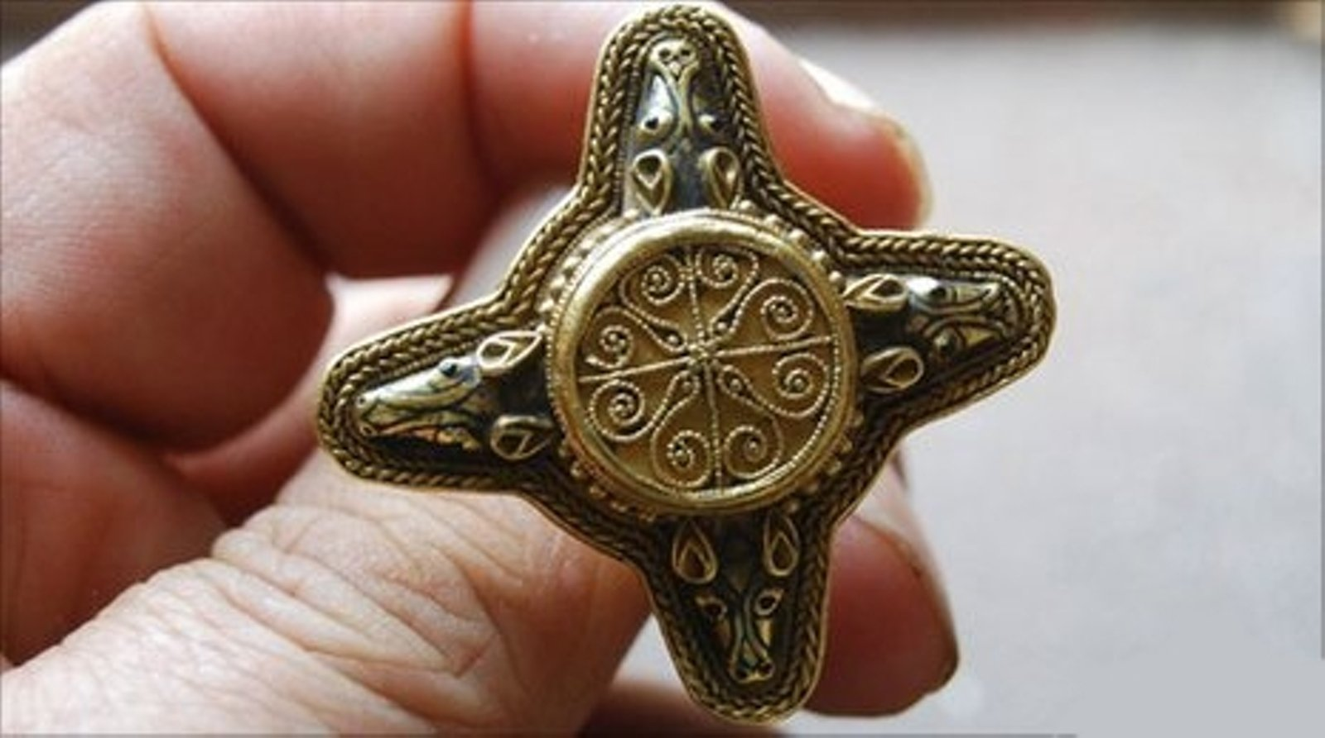
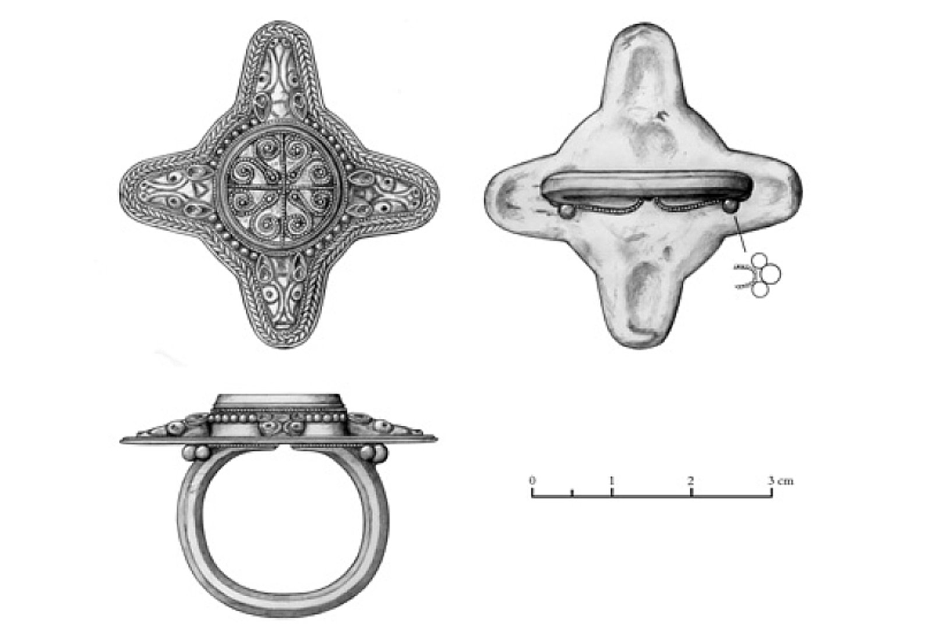

A fragment of a head from of another, similar ring, dated a bit earlier than the ring from Berkeley, is a ring found in Scrayingham in Reydale, N-Yorkshire (See more here for further information, and information on related finds). The head of the ring from Scrayingham is also a masterpiece of filigree work and has the same form/body as the head of the ring from Velbastaður and Berkely.
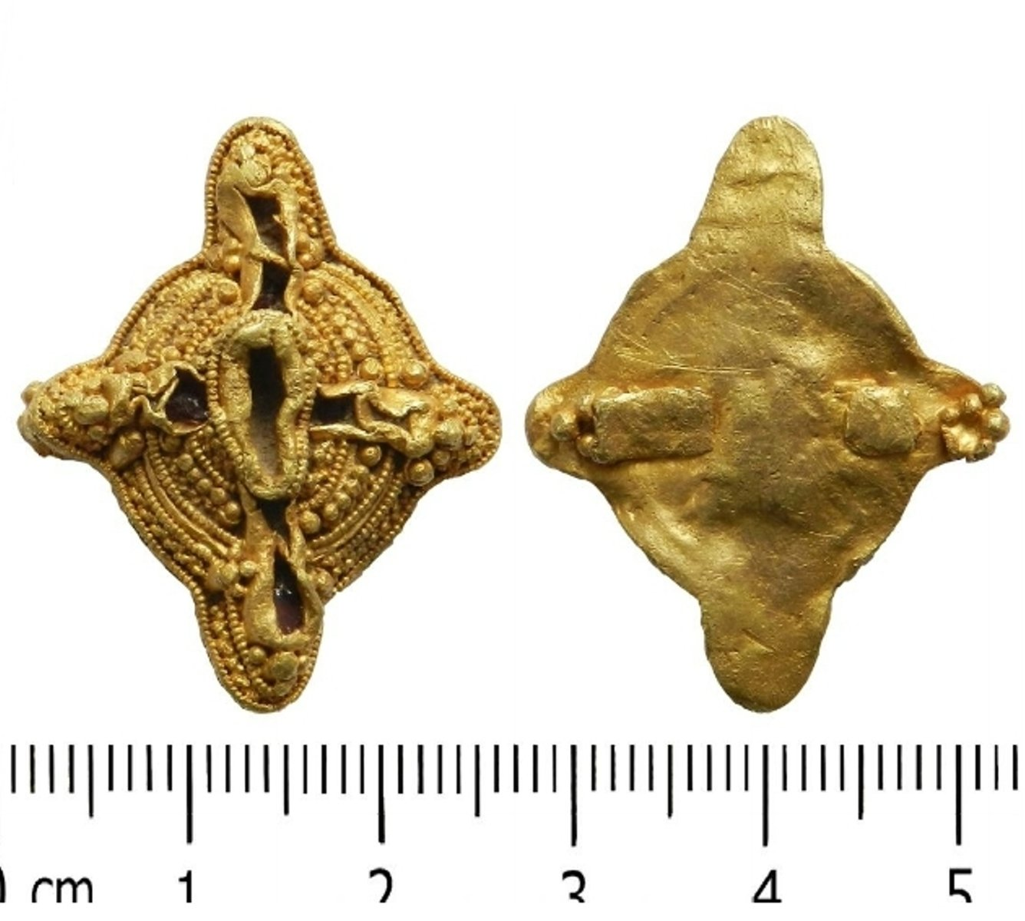
It is quite likely that the rings found at Berkley and Scrayingham have been worn by high society figures or high ranking servants of the church, an abbot or a bishop. The rings, which of course are ornamented with a different technique than the ring at Velbastaður, are good examples of the very best of jewellery making on the British Isles in the 8th and 9th centuries. The form of the heads of the British Anglo-Saxon filigree-work rings are however the same as the form of the Velbastaður-ring. This rounded-end cross shape of the head bring the centre crosses on some of the altar fronts (antemensalae) of the golden alters or the so called Gyldne Altre, of Denmark. Also I find it a interesting thought that the finger ring from Velbastaður might have been worn by a man of the Church. Why he lost his ring on the Faroe Islands is entirely his private matter, and no efforts will be put into clarifying that part of the history. Heavy drinking and priestly fornication cannot be ruled out, though.
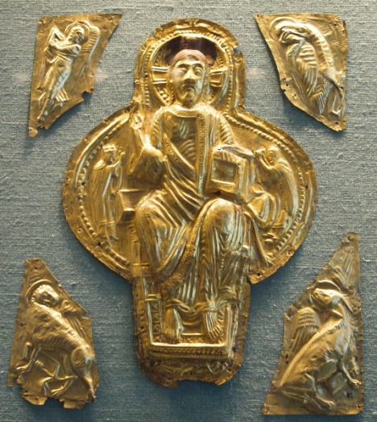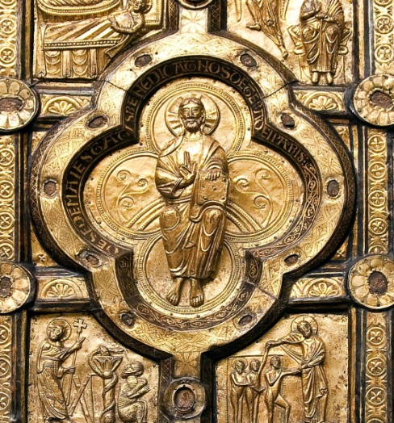
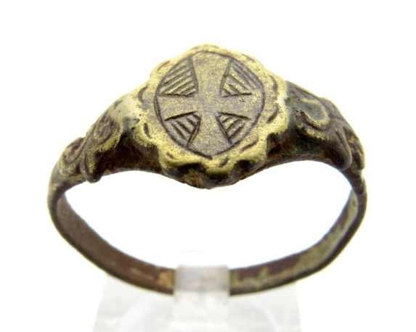
Quickly I found rings similar to the one here on the left, who bear a similar cross-image to the one on the centre of the head of the Velbastaður-ring, i.e. a Consecration Cross. It is of course far from looking anything like the seemingly unique ring from Velbastaður apart from the type of the cross.
The large silver pearls on both sides of the head on both sides of the head of the Velbastaður-ring, are likely to be stylized grapes. These the silver grapes/balls resemble similar ornament on rings from France dating from the 6th - 9th Centuries. Here below are some examples of such grapes. The grape symbolizes the blood of Christ in Christian art.
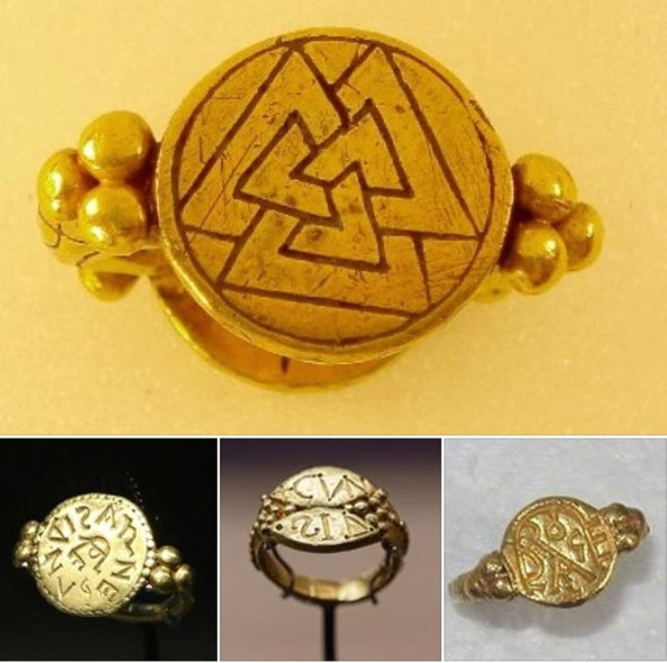

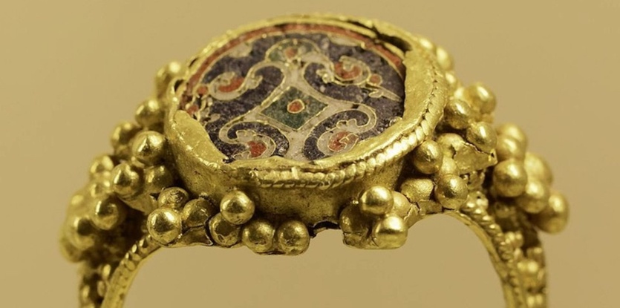
Following the wisdom of Leslie Webster, one of the prominent experts of Anglo-Saxon art in Britain, about the two filigree-rings from Berkely and Scrayingham, the ring from Velbastaður is in my opinion made in the 9th or 10th centuries, when Anglo-Saxon style and craftsmanship was still very much flourishing. The Velbastaður-ring most likely originates from the British Isles, but shows clear influences from the continent, mainly France. Some Byzantine influence cannot been excluded either.
I hope that this solves the problems with the ring from Velbastaður. And this is all from the Lord of the Rings here at the Fornleifur blog, which is mostly written in Denmark.
Farewell, or as one says in the Faroes: Allt í lagi.
Vilhjálmur Örn Vilhjálmsson

The very nice photograph at the top of this article first appeared in the Faroese journal Frøði and is taken by Finnur Justinussen.

